Autonomous AI Database Provisioning – Live Lab Insights

Introduction:

As part of my continuous learning journey in Oracle Cloud technologies, I recently completed a hands-on Live Lab on Autonomous AI Database. This lab provided practical exposure to provisioning and configuring an Autonomous Database instance within Oracle Cloud Infrastructure (OCI).

Open the Navigation menu.

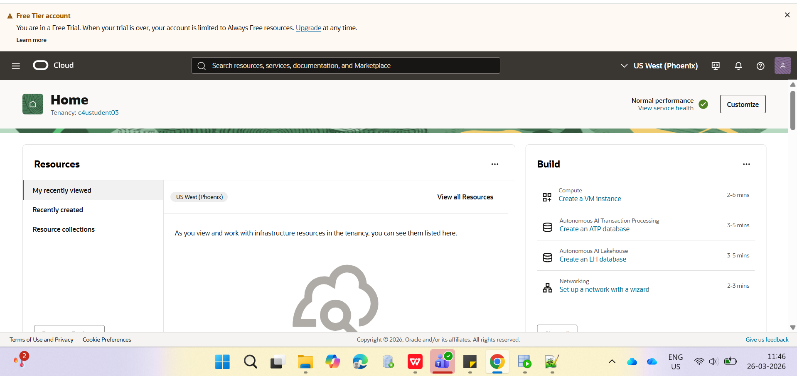

Under Oracle AI Database, click Autonomous AI Database.
The Autonomous AI Databases page is displayed.

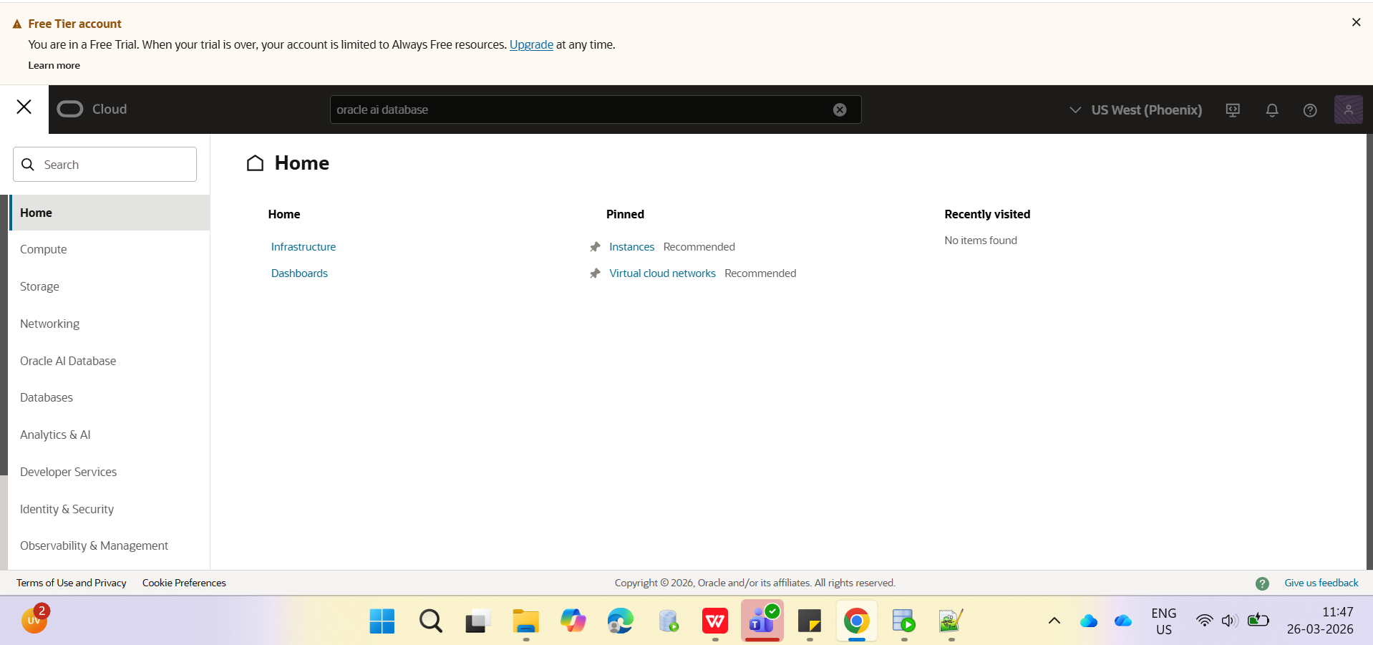

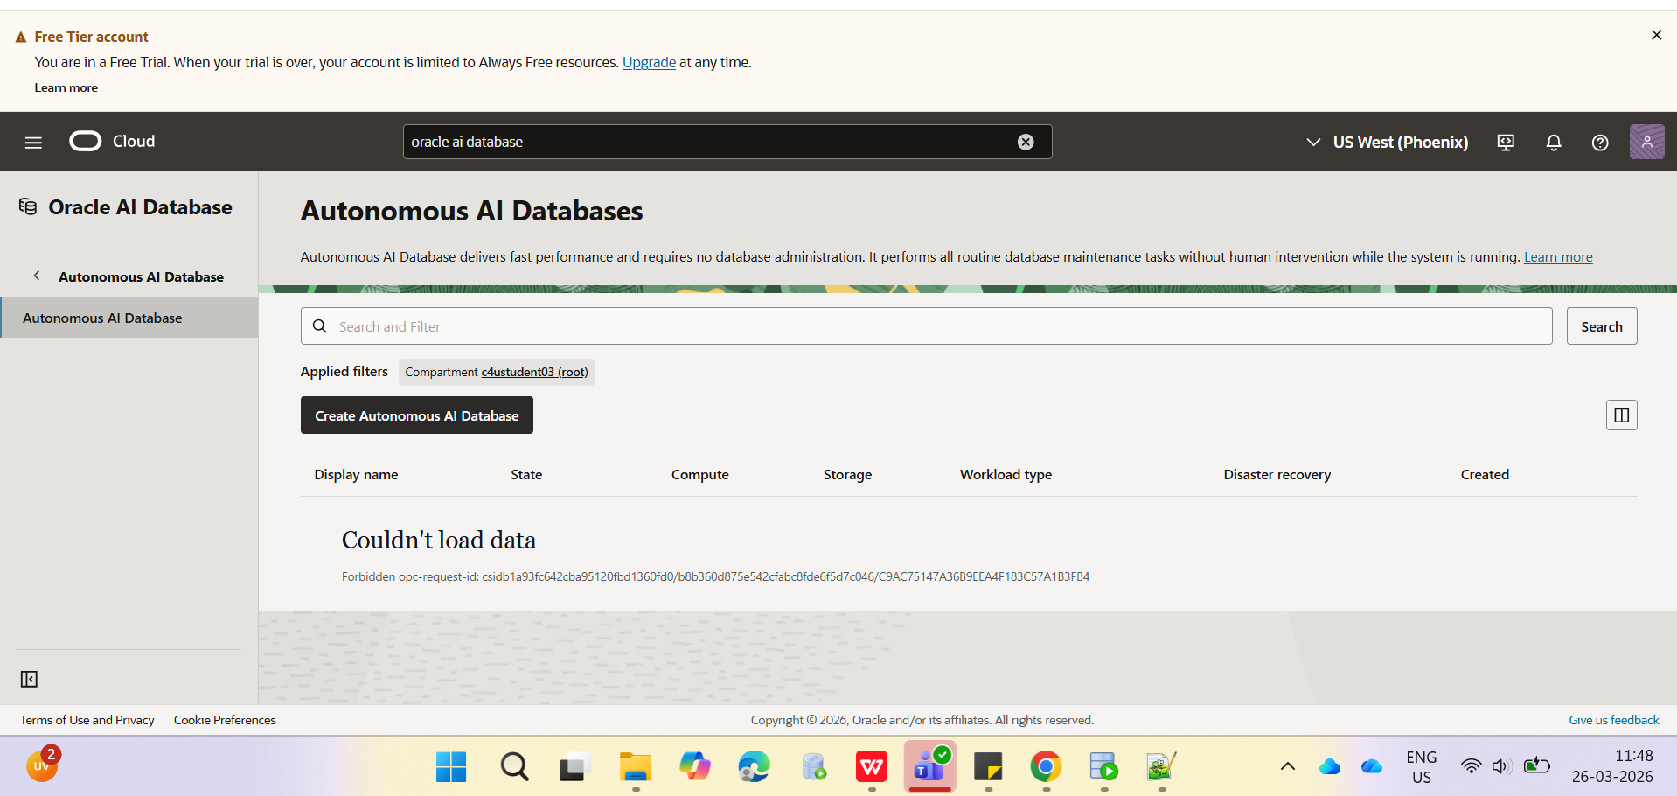

If you are using a Free Trial or Always Free account, and you want to use Always Free Resources, you need to be in a region where Always Free Resources are available. You can see your current default region in the top, right hand corner of the page.

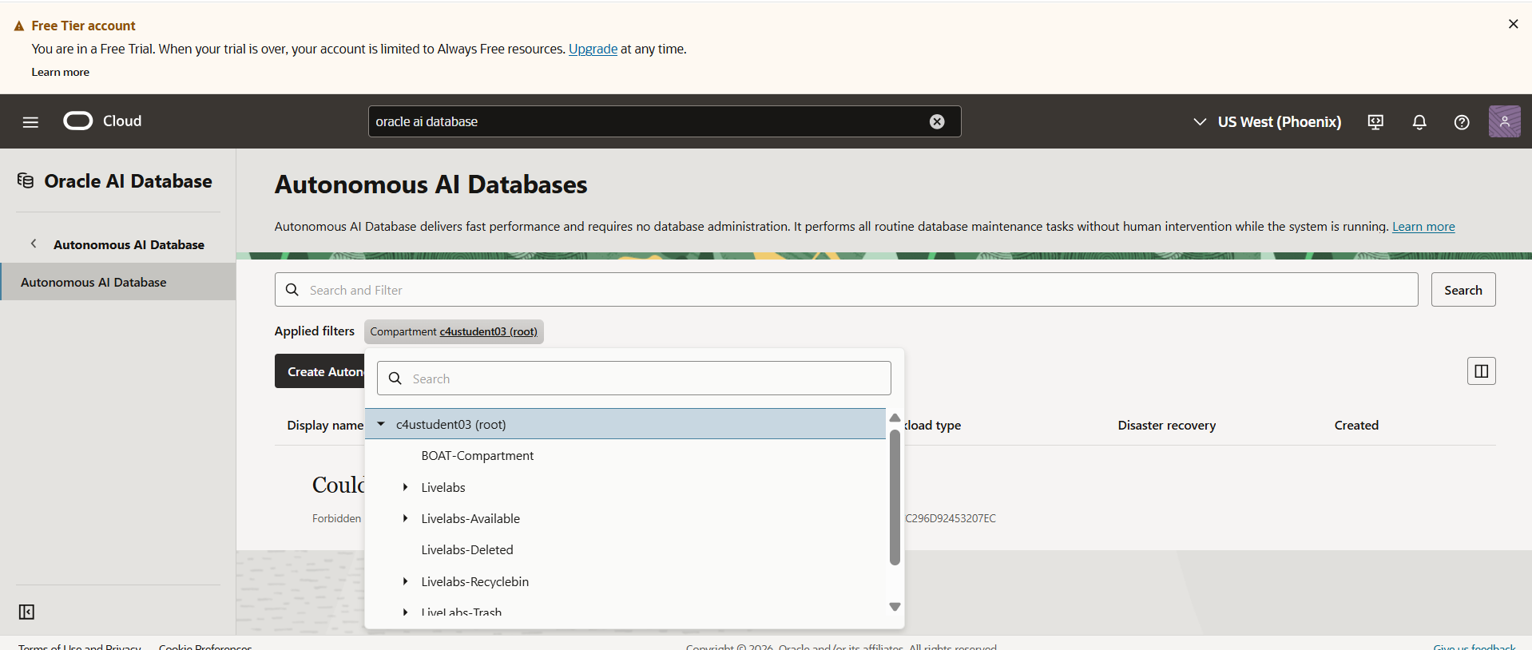

You can use the Search and Filter field to control the list of Autonomous Databases that are displayed on the page. This is useful when you are managing many Autonomous Databases. For example, you can use Workload type to filter the Autonomous Database list by selecting your workload type. You can also use the State filter to view databases that are available, stopped, terminated and much more.

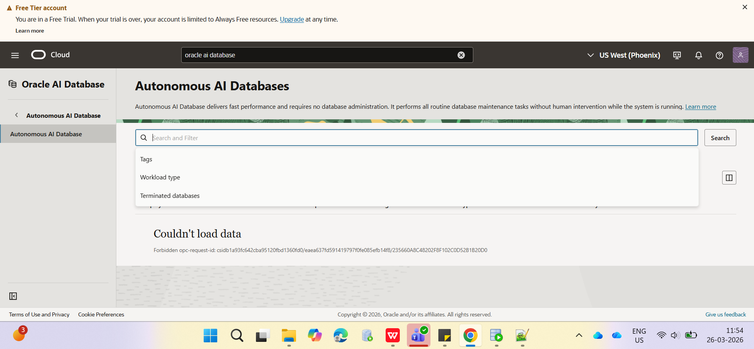

Display name: Enter a memorable name for the database for display purposes. For this lab, use MyQuickStart
Database Name: Use letters and numbers only, starting with a letter. Maximum length is 14 characters. Underscores are not supported. For this lab, use MYQUICKSTART.
Compartment: Select your compartment from the drop-down list.

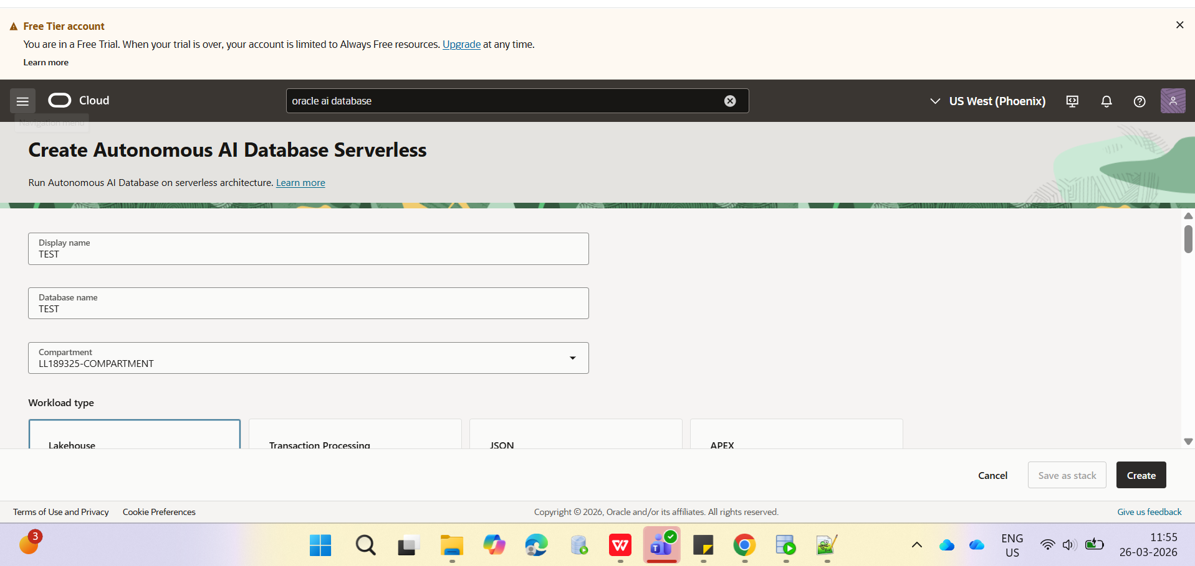

In the Workload type section, choose a workload type. Select the workload type for your database from the following choices:\
Lakehouse: Built for analytics and AI. Fast insights from a single lakehouse for all your data.
Transaction Processing: Provides all of the performance of the market-leading Oracle Database in an environment that is tuned and optimized to meet the demands of a variety of applications, including: mission-critical transaction processing, mixed transactions and analytics, IoT, and JSON document store.
JSON: It is Oracle Autonomous Transaction Processing, but designed for developing NoSQL-style applications that use JavaScript Object Notation (JSON) documents. You can store up to 20 GB of data other than JSON document collections. There is no storage limit for JSON collections.
APEX: It is a low cost, Oracle Cloud service offering convenient access to the Oracle APEX platform for rapidly building and deploying low-code applications.
For this workshop, accept the Lakehouse default selection.
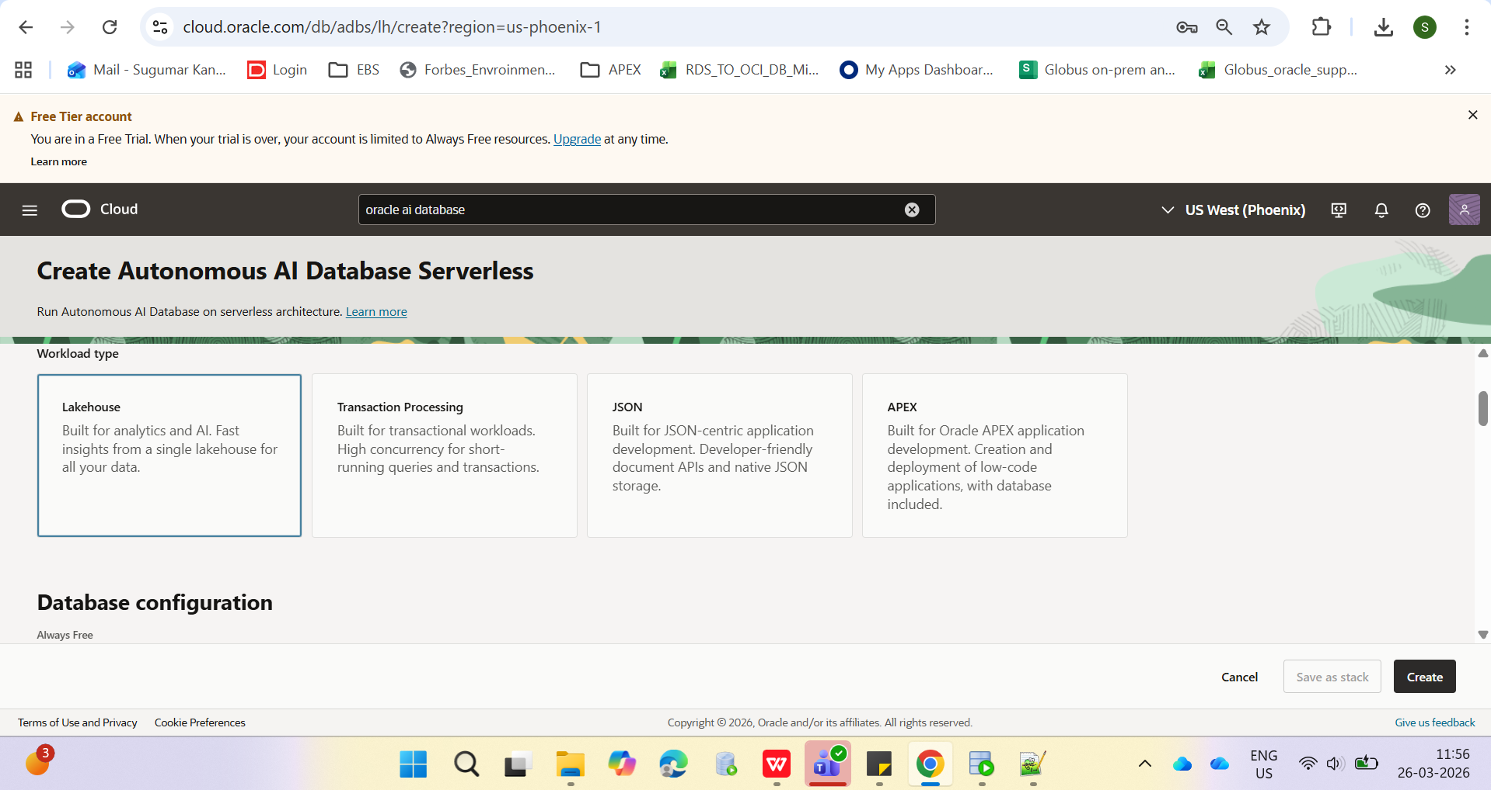

In the Database configuration section, specify the following:
Always Free: An Always Free databases are especially useful for development and trying new features. You can deploy an Always Free instance in an Always Free account or paid account. However, it must be deployed in the home region of your tenancy. The only option you specify in an Always Free database is the database version. For this lab, we recommend you leave the Always Free slider disabled unless you are in an Always Free account.
Developer: Developer databases provide a great low cost option for developing apps with Autonomous AI Database. You have similar features to Always Free - but are not limited in terms of region deployments or the number of databases in your tenancy. You can upgrade your Developer Database to a full paid version later and benefit from greater control over resources, backups and more. For this lab, leave the Developer slider disabled.
Choose database version: Select 26ai for the database version from this drop-down list.
ECPU count: Choose the number of ECPUs for your service. For this lab, specify 2 ECPUs. If you choose an Always Free database, you do not need to specify this option.
Compute auto scaling: Accept the default which is enabled. This enables the system to automatically use up to three times more compute and IO resources to meet workload demand.
Storage (TB): Select your storage capacity in terabytes. For this lab, specify 1 TB of storage. Or, if you choose an Always Free database, it comes with 20 GB of storage.

Storage auto scaling: For this lab, there is no need to enable storage auto scaling, which would allow the system to expand up to three times the reserved storage. Accept the default which is disabled.
Note: You cannot scale up/down an Always Free Autonomous AI Database.
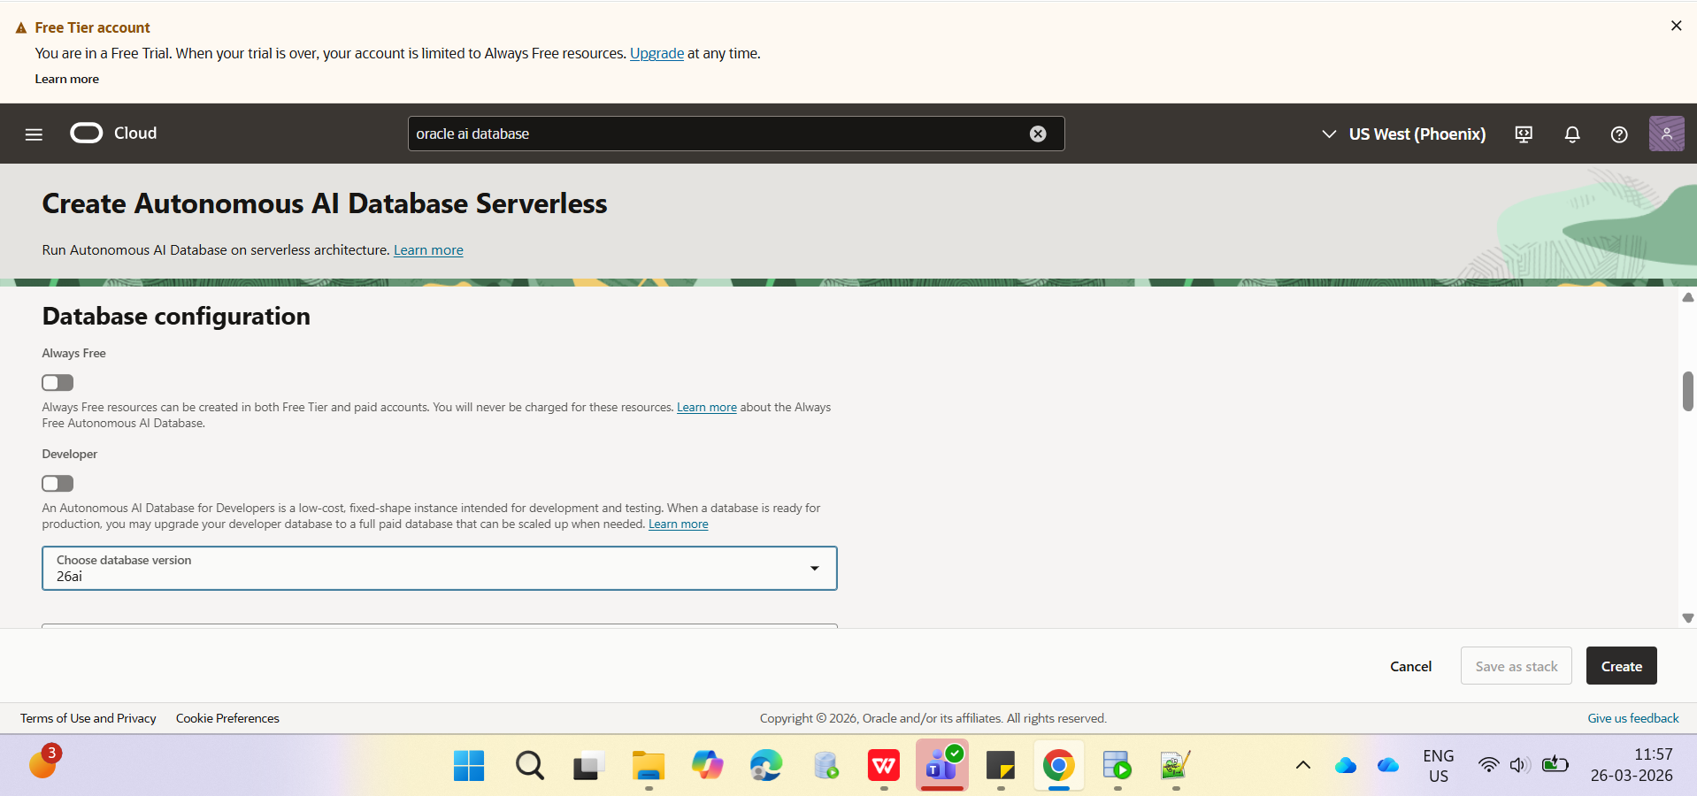

In the Backup section, specify the following:
Automatic backup retention period in days: You can either accept the default value or specify your own preferred backup retention days value. For this lab, accept the default 60 days default value.
Immutable backup retention: Accept the disabled default selection.

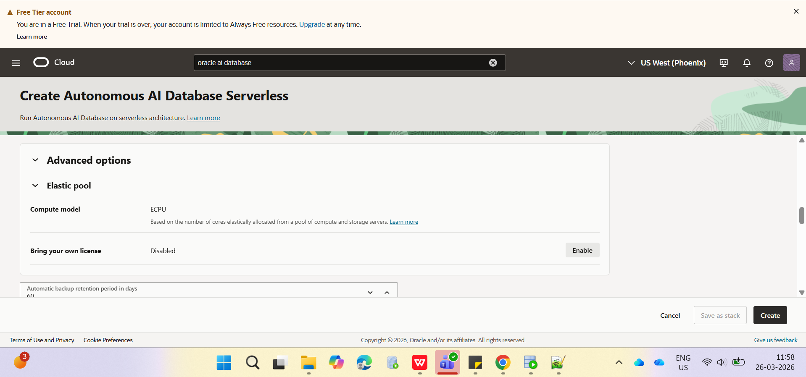

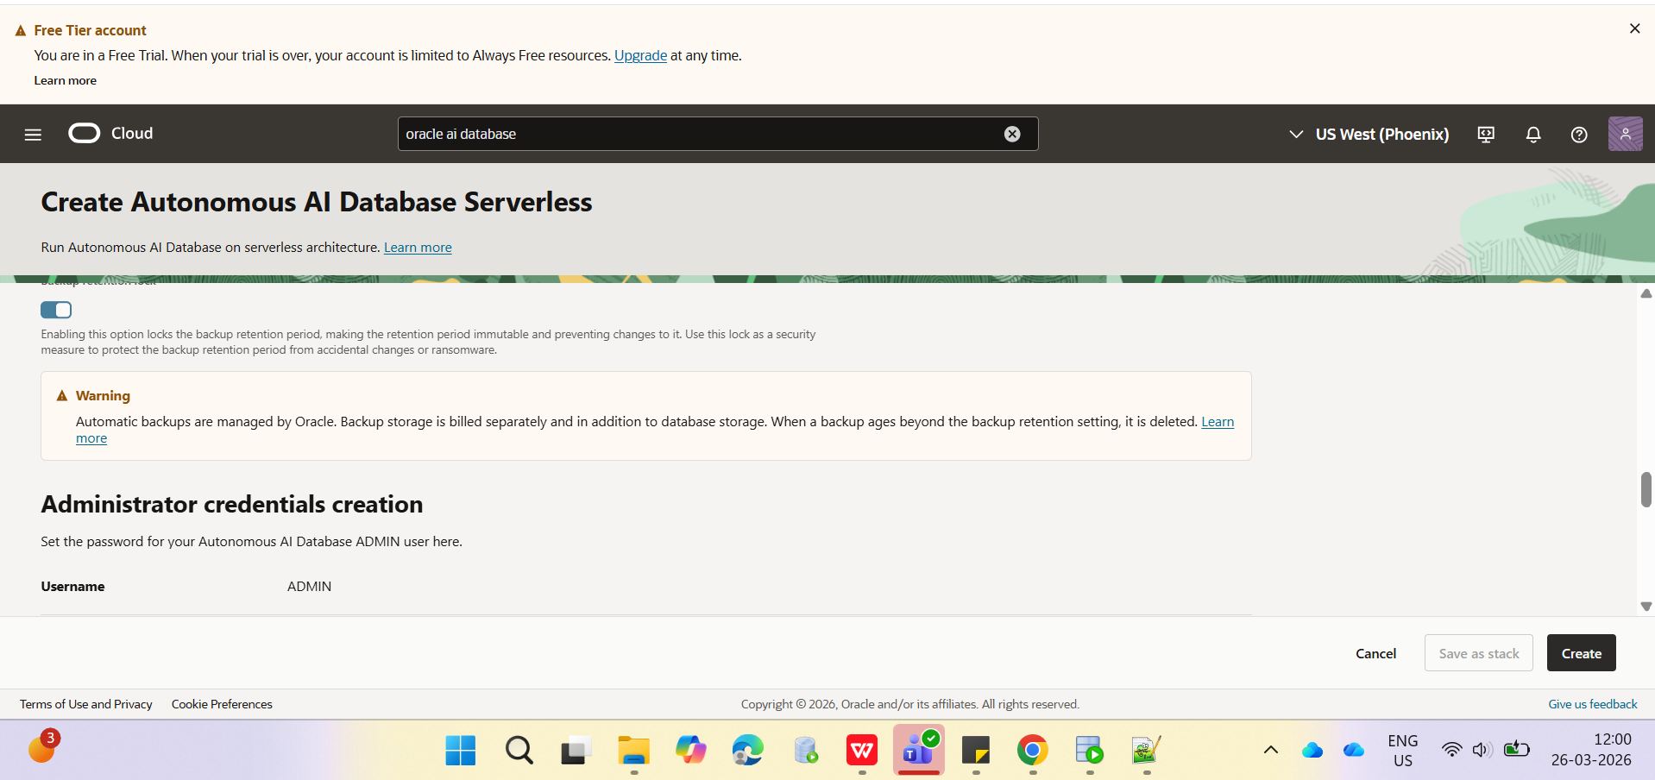

In the Administrator credentials creation section, specify the following:
Username: This read-only field displays the default administrator username, ADMIN. Important: Make a note of this username as you will need it to perform later tasks.
Password: Enter a password for the ADMIN user of the service instance choice such as Training4ADW. Important: Make a note of this password as you will need it to perform later tasks.
Confirm password: Confirm your password.

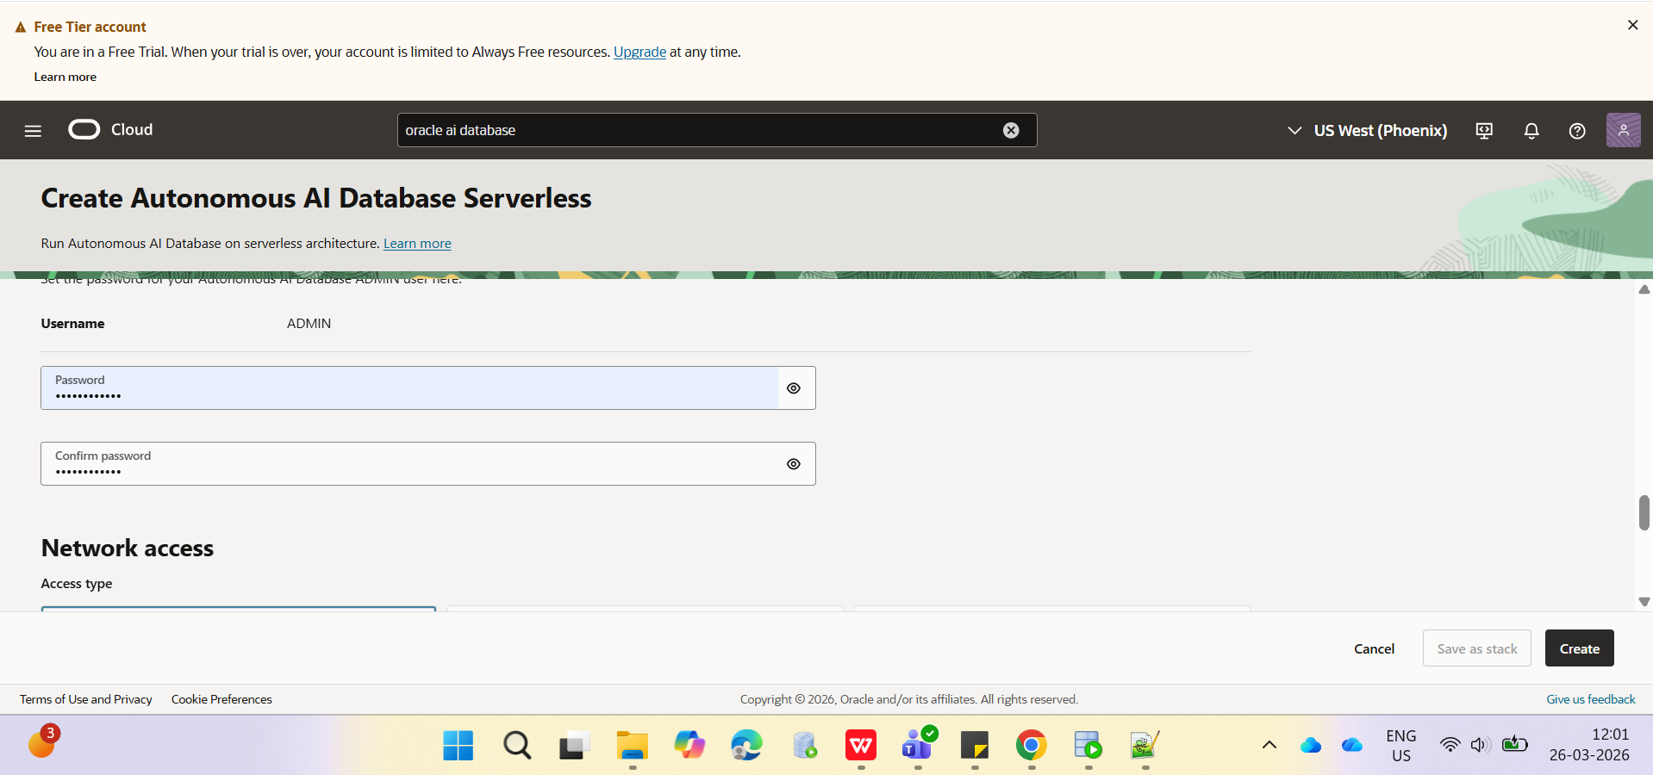

If you want to allow traffic only from the IP addresses and VCNs you specify - where access to the database from all public IPs or VCNs is blocked, select Secure access from allowed IPs and VCNs only in the Choose network access area.
If you want to restrict access to a private endpoint within an OCI VCN, select Private endpoint access only in the Choose network access area.
If the Require mutual TLS (mTLS) authentication option is selected, mTLS will be required to authenticate connections to your Autonomous AI Database. TLS connections allow you to connect to your Autonomous AI Database without a wallet, if you use a JDBC thin driver with JDK8 or above. See the documentation for network options for options to allow TLS, or to require only mutual TLS(mTLS) authentication.
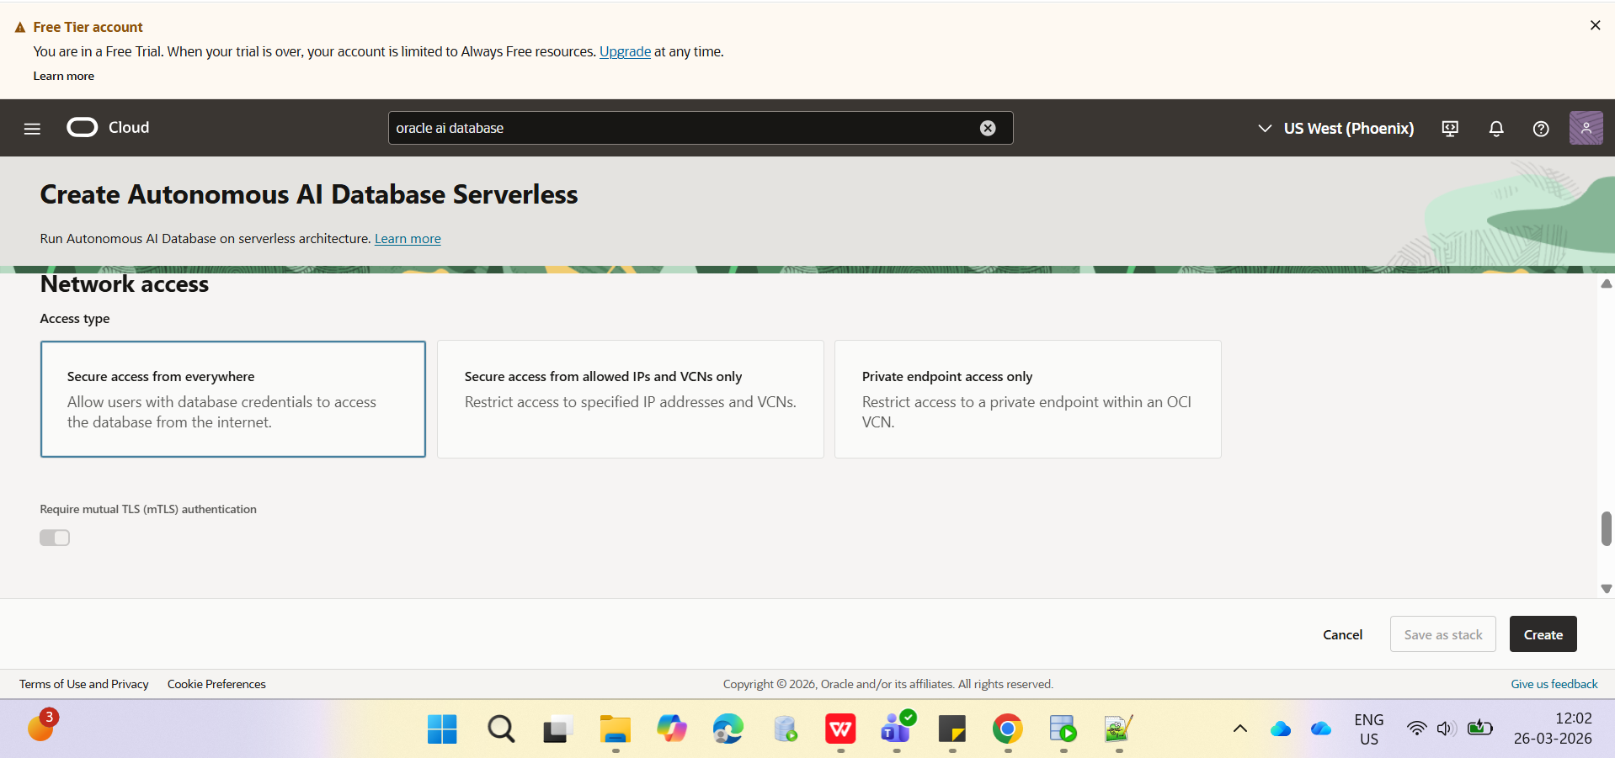
In the Contacts for operational notifications and announcements section, provide a contact email address. The Contact email field allows you to list contacts to receive operational notices and announcements as well as unplanned maintenance notifications.

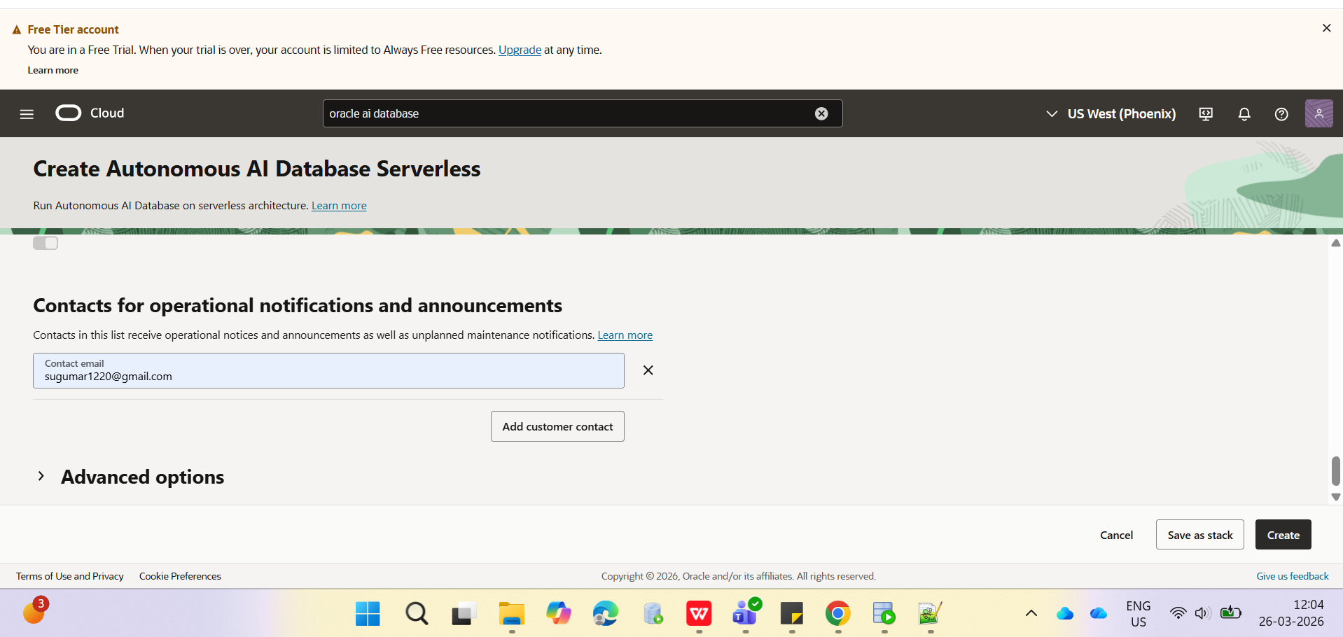

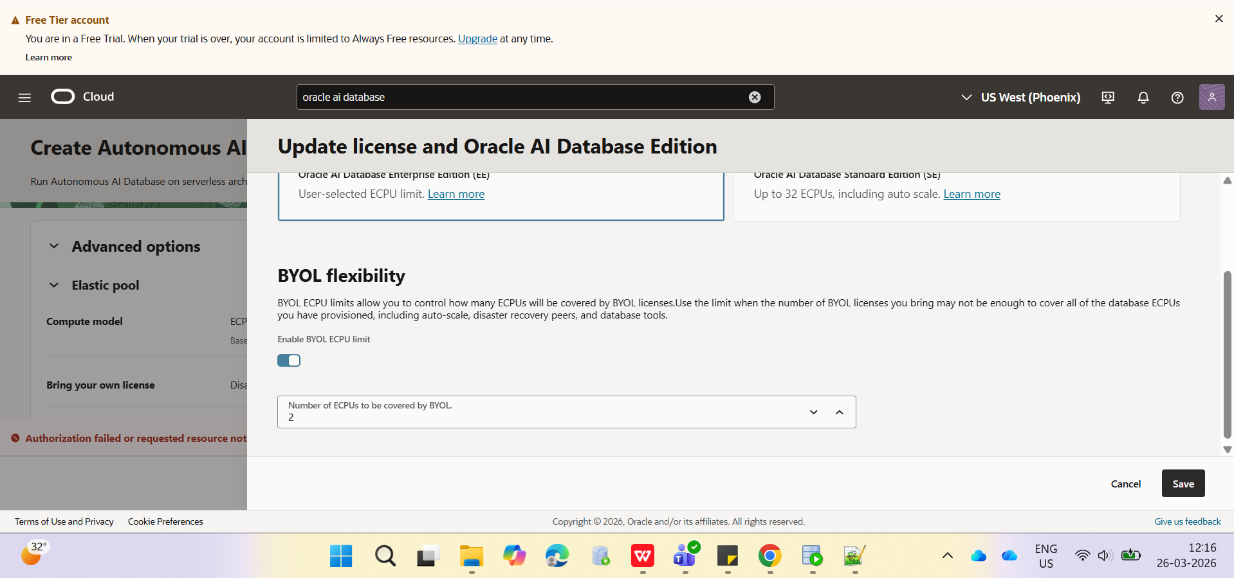

Click Create.The Autonomous AI Database details page is displayed. The status of your ADB instance is Provisioning.
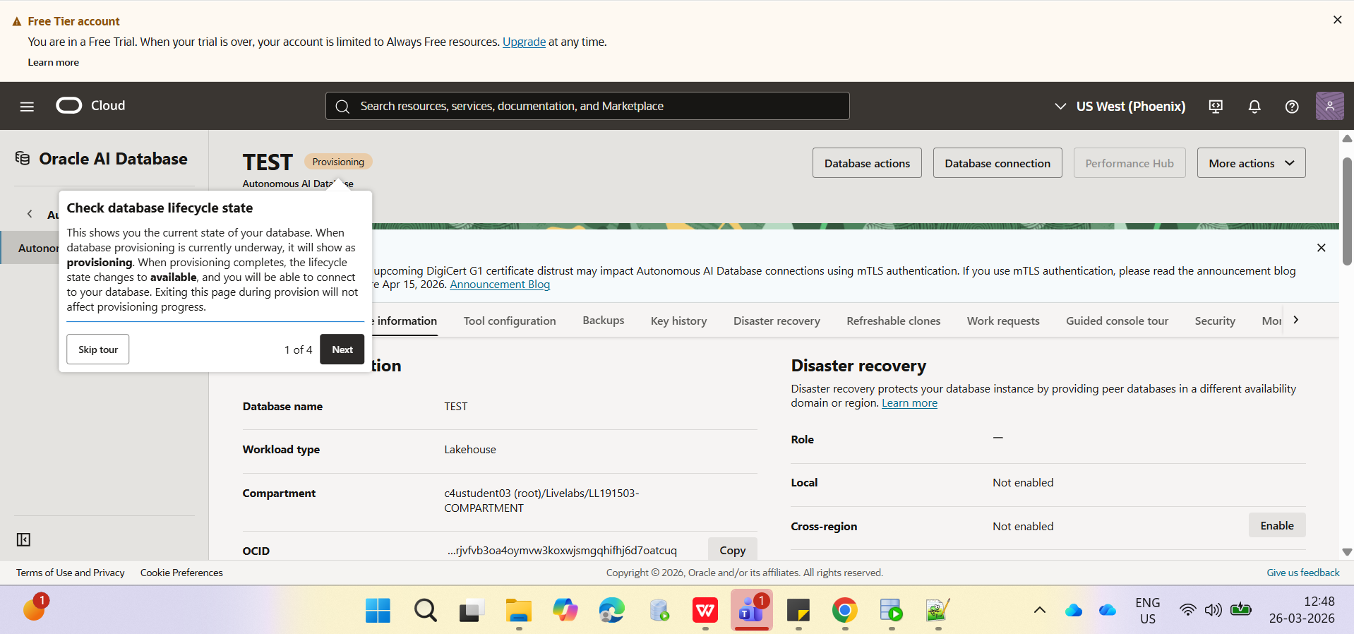
A Check database lifecycle state informational box is displayed. You can navigate through this tour or choose to skip it. Click Skip tour. A Skip guided tour dialog box is displayed. Click Skip.
In a few minutes, the instance status changes to Available. At this point, your Autonomous Data Warehouse database instance is ready to use! Review your instance's details including its name, database version, ECPU count, and storage size.
Note: In the following screen sample, the database display name is Training-Database and the database name is TrainingDatabase. In your example, your database display name and database name might be different.

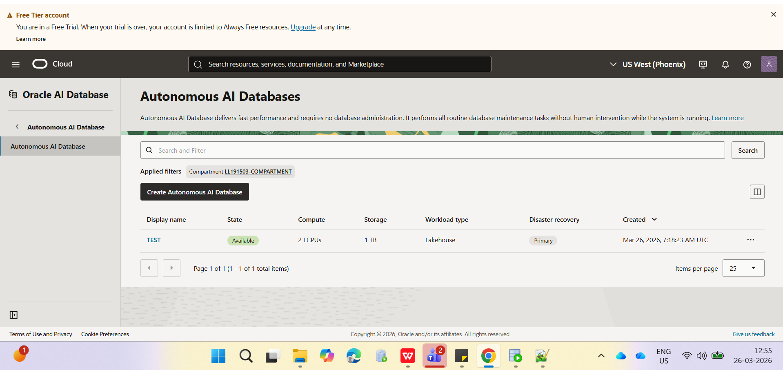

Click the Autonomous AI Databases link in the top left of the page. The Autonomous AI Database page is displayed.

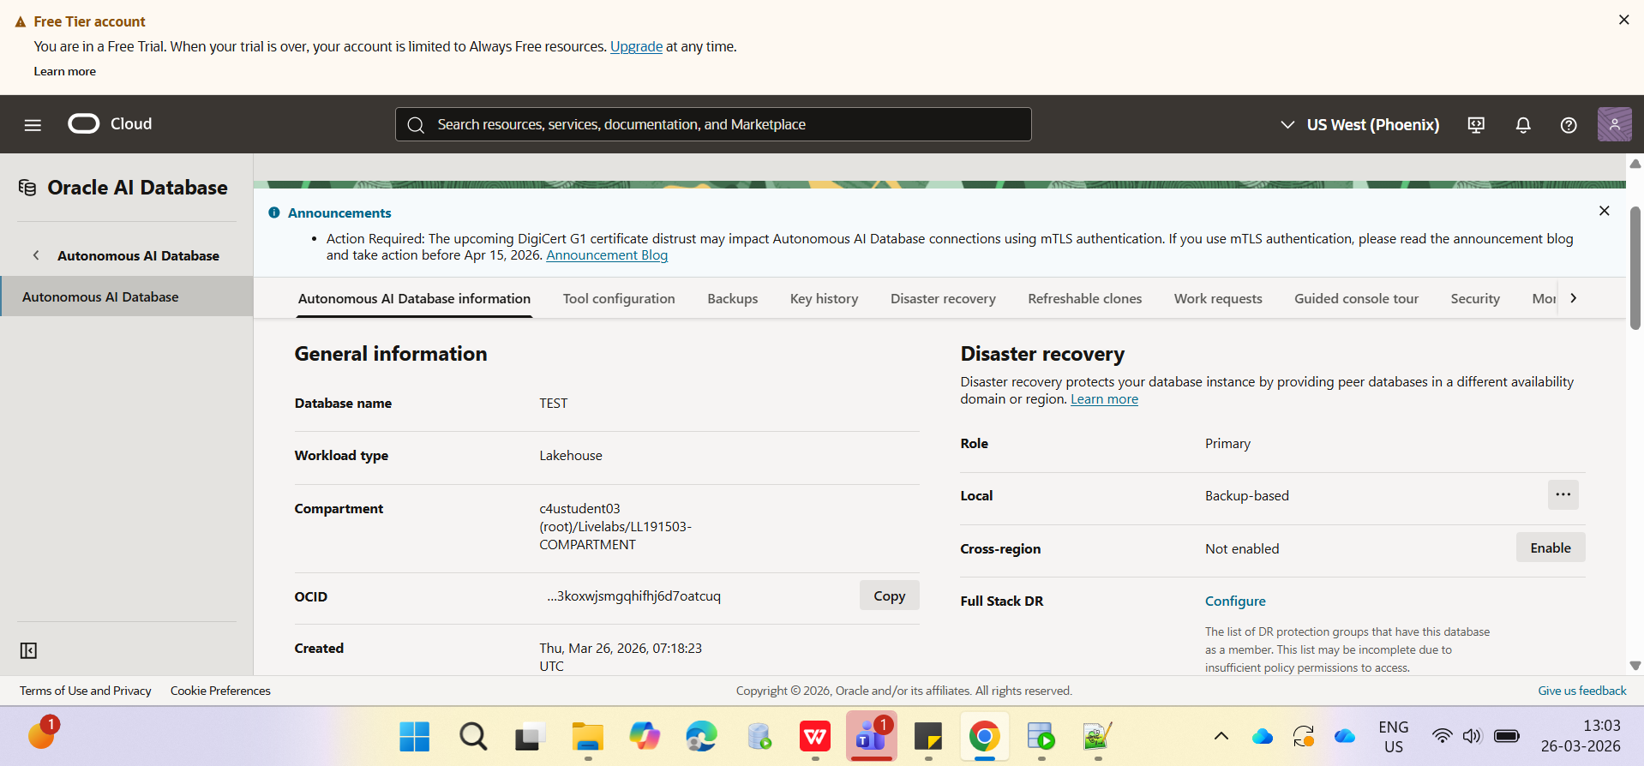

An email message is sent to the contact email that you provided. The email contains useful links that you can use to launch Database Actions, view the Get Started with Autonomous AI Database Web page, and access the online forums to post a question and collaborate with other Autonomous AI Database experts.

